7 Moving the Cursor
10/19/2026

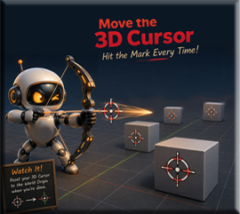
If you do not see the cursor, you will need to turn it on
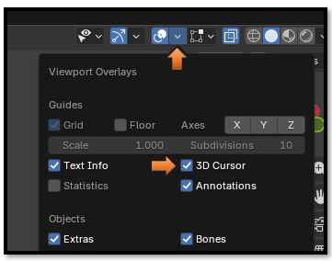

There are two easy ways to position the 3D Cursor: using the Cursor tool or the keyboard shortcut..

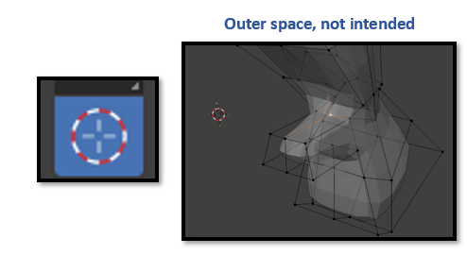

Hot Key
Shift -S, Cursor to Selected
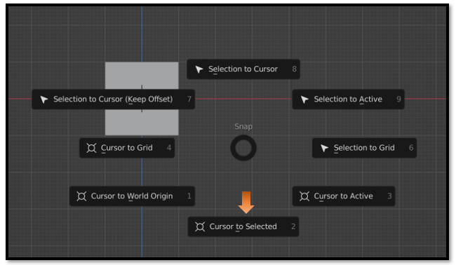
And it should jump to just about any thing in the View port that we select. In this image, we selected a vertex, hit the button that says ‘Cursor to Selected’ Now that cursor is now positioned exactly at that point. No guessing required.
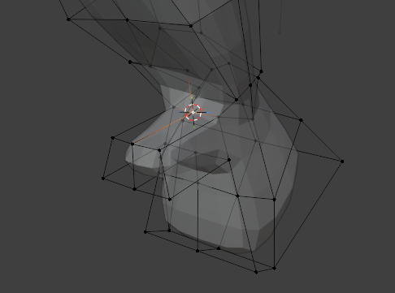
This can be extremely useful for things like:
• Add an Image reference.
• Place an Empty (an invisible object often used as a reference or animation control).
• Position a new bone.
• Begin modeling from an exact point on your mesh.

Just Remember to reset your cursor back to the World Origin, when you are done.
